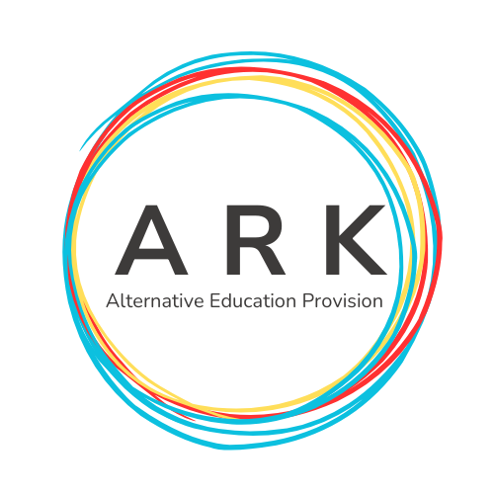

ARK AEP Centre Monitoring Policy 2025

# Purpose

The purpose of this policy is to ensure the highest standards of quality and integrity in the delivery of ASDAN qualifications within ARK AEP. This policy outlines the procedures for monitoring and evaluating the effectiveness of our educational provision, ensuring compliance with regulatory requirements, and promoting continuous improvement.

# Scope

This policy applies to all staff, assessors, moderators, and any third parties involved in the delivery of ASDAN qualifications within ARK AEP.

# Monitoring Objectives

The objectives of centre monitoring are to:  
- Ensure compliance with ASDAN and regulatory requirements.  
- Maintain the integrity and quality of assessment and certification processes.  
- Identify areas for improvement and implement action plans.  
- Support staff in delivering high-quality education and training.

# Roles and Responsibilities

The following roles and responsibilities are defined for effective centre monitoring:  
- Centre Manager: Oversees the implementation of the monitoring policy and ensures compliance with ASDAN requirements.  
- Quality Assurance Lead: Coordinates monitoring activities, conducts audits, and provides feedback to staff.  
- Assessors and Moderators: Participate in monitoring activities, provide evidence of compliance, and implement action plans.  
- External Verifiers: Conduct external audits and provide independent verification of compliance.

# Monitoring Activities

Monitoring activities include:  
- Observations: Regular observations of teaching, learning, and assessment practices to ensure compliance and identify areas for improvement.  
- Sampling: Random sampling of learner work and assessment records to verify the accuracy and consistency of assessment decisions.  
- Audits: Comprehensive audits of centre processes, documentation, and records to ensure compliance with ASDAN and regulatory requirements.  
- Feedback: Collection of feedback from learners, staff, and stakeholders to inform continuous improvement.

# Reporting and Feedback

Monitoring reports will be produced following each monitoring activity and will include:  
- Summary of findings.  
- Areas of good practice.  
- Areas for improvement.  
- Action plans with clear timelines and responsibilities.  
Feedback will be provided to staff and stakeholders to support continuous improvement and ensure transparency.

# Action Planning

Action plans will be developed to address areas for improvement identified through monitoring activities. These plans will include specific actions, timelines, and responsibilities. Progress against action plans will be reviewed regularly to ensure timely implementation and effectiveness.

# Review

This policy will be reviewed annually or when significant changes occur to ensure its continued relevance and effectiveness. The review will consider feedback from monitoring activities, changes in regulatory requirements, and best practices in quality assurance.

Signed-

K Walton- June 2025

A Middlemas- June 2025