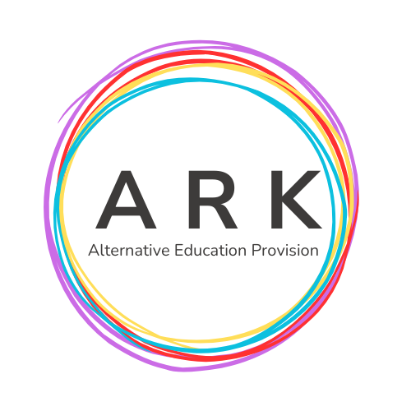
ARK Alternative Provision Admissions Form 2026

ARK Mission Statement-2026
ARK Alternative Education Provision is committed to placing every learner at the heart of everything we do. We provide tailored academic, social and personal support for young people aged 12 to 16 across Hull and the East Riding, creating safe, happy and inclusive learning environments where learners feel valued, celebrated and ready to grow.
Through bespoke learning packages, Functional Skills, ASDAN programmes, wellbeing support, employability guidance and project-based learning, Team ARK empowers, nurtures and challenges learners to become the very best version of themselves. We support learners to make positive and safe choices, believe in their potential and develop the confidence, skills and aspirations needed for successful futures.
Our mission is underpinned by a culture of safety, inclusion, acceptance, respect, kindness, aspiration, empathy and positivity. Safeguarding is central to every aspect of our work, and we work closely with families, providers and external services to ensure that every learner is supported, encouraged, challenged and empowered to learn, thrive and succeed.
DSL-Kay Walton- kay.walton@arkaep.co.uk
07534861484
DDSL-Allison Middlemas- allison.middlemas@arkaep.co.uk
07526249516

Website- www.arkaep.co.uk

Learner Name:  Name liked to be known as: |  |  |  |  |  |  | Pop a photo of you in here!
Year Group on admission:
Current Setting/Previous Settings:
Remote Learning:
Onsite Learning:
Date Started at ARK Setting: |  |  |  |  |  |  | Admission meeting date-
Health Information:  Dietary Requirements Y N  Medical Needs Y N  Consent to support with first aid and emergency medical care Y N  Further Medical Information- |  |  |  |  |  |  | Home Contact Name:  Relationship to child:  Home address:  Contact numbers:  Emergency contact name/relationship to child/number:
ARK Sessions: |  |  |  |  | Other Information re sessions |  | Consent -Please Circle
M | T | W | Th | F |  |  | Can this learner go out independently at break/lunch? Y N
 |  |  |  |  |  |  | Can this learner attend trips/activities offsite? Y N
Do staff have consent to take a photo and publish on the provision website? Y N

Parent/Carer takes responsibility for any damage to ARK property and works with ARK to resolve this- Y N
Further Information:
Looked After Child: |  |  |  |  |  | Yes/No | Early Help Support | Yes/No
EHC/Support/Safety Plan |  |  |  |  |  | Yes/No | Child Protection Plan: | Yes/No
Contact Details – Child Protection Officer:
SEMH: Yes/No
Broad Area of Need  (Please Circle) |  |  |  |  |  |  | Other Professionals Involved  (Please Circle)
Communication and Interaction |  |  |  |  |  |  | Educational Psychologist
Cognition and Learning |  |  |  |  |  |  | CAMHS
Social. Emotional and Mental Health |  |  |  |  |  |  | Speech and Language Therapist
Sensory Needs |  |  |  |  |  |  | Occupational Therapist
Physical Needs |  |  |  |  |  |  | Other (Please specify below)
Stage of SEND Support (Please specify)

Learner Section-
All About Me
Favourite Lesson/Learning time-

What I need from my learning setting-
*Lesson

*Social time

*Adults

*Peers

Dream Job-

