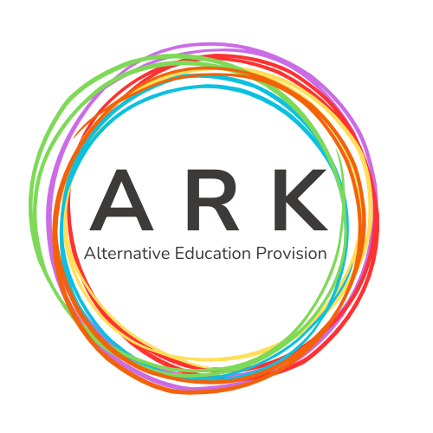

ARK AEP Risk Assessment Policy
Effective Date | 01.08.25
Review Date | 01.08.26
Approved By | Allison Middlemas - Director of Operations

1. Policy Statement
ARK Alternative Education Provision (AEP) is committed to providing a safe, secure, and healthy environment for all students, staff, and visitors. This policy sets out the formal arrangements for systematically identifying, assessing, and managing all significant risks that may threaten the health, safety, welfare, and learning outcomes of our stakeholders, and the achievement of the AEP's objectives. Risk assessment is a cornerstone of our safeguarding, health and safety, and operational management strategy.

2. Scope
This policy applies to all activities undertaken by ARK AEP, including:
- All premises and working environments used by ARK AEP.
- All educational, vocational, and recreational activities.
- Off-site activities, including educational visits, work placements, and community engagement.
- All students, staff (permanent, temporary, and agency), volunteers, and visitors.
- Specific risks relating to individual student needs, particularly those with complex or challenging behaviours (Individual Risk Assessments).

3. Definitions and Principles
Term | Definition
Hazard | Something with the potential to cause harm (e.g., a wet floor, a student's history of aggression).
Risk | The likelihood that harm will occur from a hazard, and the severity of that harm.
Risk Assessment | A careful examination of what, in a place of work, or activity, could cause harm to people, so that you can weigh up whether you have taken enough precautions or should do more.
Control Measure | Actions taken to eliminate the hazard or reduce the risk to an acceptable level.
Individual Risk Assessment (IRA) | A specific assessment focusing on the risks posed by, or to, an individual student, often linked to their Education Health and Care (EHC) plan or specific needs.
Export to Sheets
Guiding Principles:
- All significant risks must be identified, assessed, and recorded.
- Risks must be reduced to a level that is As Low As Reasonably Practicable (ALARP).
- Risk assessments must be suitable and sufficient, considering all those who may be affected, including those who may be particularly at risk (e.g., young, inexperienced, or vulnerable staff/students).

4. The 5 Steps to Risk Assessment (ARK AEP Procedure)
The risk assessment process will follow the widely recognised five-step method:

Step 1: Identify the Hazards
The assessor will walk around the provision, observe activities, consult with staff and students, and review accident/incident records to identify anything that could cause harm. In AEP, this includes physical hazards, but also safeguarding/welfare risks (e.g., online safety, peer-on-peer abuse, radicalisation) and behavioural risks (e.g., violence, self-harm).

Step 2: Decide Who Might be Harmed, and How
Identify groups of people (e.g., teaching staff, students, cleaners, lone workers) and how they could be harmed by the identified hazard. Particular attention must be paid to vulnerable students and staff who may be disproportionately affected.

Step 3: Evaluate the Risks and Decide on Control Measures
The risk will be evaluated based on the potential Likelihood of harm and the potential Severity of the harm.
- Risk Matrix: A simple 3×3 or 5×5 matrix will be used to score the risk.
  - Example: Likelihood (1-5) × Severity (1-5) = Risk Score (1-25)
- Hierarchy of Control: Control measures will be applied in order of priority:
  - Eliminate the risk (e.g., stop the activity).
  - Substitute the hazard (e.g., use a safer chemical).
  - Engineering Controls (e.g., guards, ventilation).
  - Administrative Controls (e.g., safe working procedures, training, supervision ratios).
  - Personal Protective Equipment (PPE) (e.g., gloves, safety glasses - as a last resort).

Step 4: Record Findings and Implement Controls
Significant findings must be formally recorded on the ARK AEP Risk Assessment form. The record must detail the required actions, who is responsible for implementation, and the deadline. All staff must be made aware of the findings and the necessary controls.

Step 5: Review and Update the Assessment
Risk assessments are not static documents. They must be reviewed:
- Periodically (at least annually, as per the review date).
- Following an incident or near-miss.
- When there is a significant change to the environment, equipment, working practices, or student cohort.

5. Roles and Responsibilities
Role | Responsibility
Director of Operations & Learning | Overall responsibility for ensuring the policy is implemented, monitored, and reviewed. Provides resources for risk control.
Manages the risk assessment programme, maintains a central register of all risk assessments, and provides advice and training.
To conduct, implement, and review risk assessments for their specific areas of responsibility and activities.
All Staff | To cooperate with the risk assessment process, follow control measures, and report new or emerging hazards immediately to their line manager.

6. Individual Risk Assessments (IRAs)
For students whose behaviour or needs present an elevated risk to themselves or others (e.g., due to self-harm, aggression, specific medical needs, or involvement in CCE/Gangs), a dedicated Individual Risk Assessment (IRA) will be completed and maintained.
- IRAs will be developed in consultation with the student (where appropriate), parents/carers, and relevant external agencies (e.g., Social Services, CAMHS).
- The IRA will detail specific control measures, support plans, de-escalation strategies, and required staff training/supervision ratios.
- IRAs must be reviewed regularly, especially after any significant change in behaviour or incident.

7. Documentation and Record Keeping
A central register of all current risk assessments, including generic and specific assessments, will be maintained by the Policy Owner.
- All risk assessment forms must be completed, dated, signed, and communicated.
- Records will be kept for [Insert time, e.g., 5 years] from the date of the review or until superseded.

8. Related Policies
This policy must be read in conjunction with the following ARK AEP policies:
- Safeguarding and Child Protection Policy
- Behaviour Management Policy
- Health and Safety Policy
- Educational Visits Policy
- Lone Working Policy

