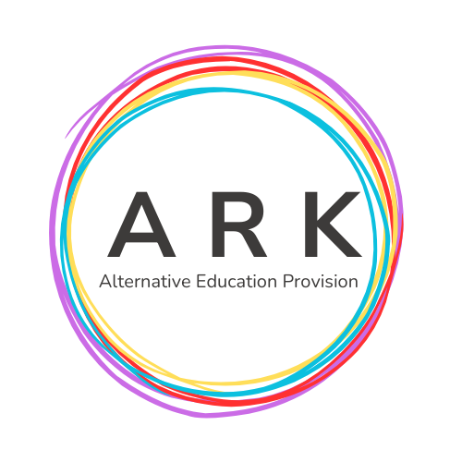

ARK AEP Complaints Policy- JAN 2026

1. Introduction
ARKAEP is committed to delivering a high-quality service to all learners, parents, carers, partners, and stakeholders. We recognise that concerns may arise, and we aim to resolve them promptly, fairly, and transparently.

2. Purpose of the Policy
This policy ensures that complaints are handled consistently and respectfully, individuals understand how to raise concerns, outcomes are fair and timely, and learning from complaints contributes to service improvement.

3. What Is a Complaint?
A complaint is any expression of dissatisfaction about ARKAEP’s actions, decisions, services, or staff, where a response or resolution is expected.

4. How to Make a Complaint
We encourage informal resolution where possible. If the issue cannot be resolved informally, a formal complaint may be submitted via email, telephone or in person if appropriate. Contact number - 07534861484
Email- kay.walton@arkaep.co.uk/allison.middlemas@arkaep.co.uk

5. Independent Complaints Professional
If a complainant feels their complaint has not been dealt with fairly, or they remain dissatisfied after ARKAEP’s internal process is complete, they may request an independent review.
ARK’s Independent Complaints Professional is Brian Swinton. Brian is a retired educator and former Regional Officer for the National Union of Teachers (NUT).
Brian can be contacted on:
- 07738 656842
- 01482 346452

6. Timescales
Acknowledgement within 5 working days. Full response normally within 20 working days.

7. Confidentiality
All complaints are handled sensitively and information is shared only with those involved in investigating or resolving the matter.

8. Monitoring and Review
ARKAEP records and reviews complaints to identify themes, improve practice, and ensure accountability. This policy is reviewed annually.

Reviewed by- Kay Walton
Review Date- 11.01.26

